// Assignment no-4(2)

// Name- Prerana Rajesh Gajare Class-SEIT RollNo-SI41

/\*PROBLEM STATEMENT:-

4. Write an Embedded C program for sorting the numbers in descending order.

\*/

//Source Code:-

#include <xc.h>

#include <stdio.h>

#include <stdlib.h>

#include <pic18f4550.h>

void main(void)

{ int i, j, t;

int a[]={ 0x45 , 0x03 , 0x06 ,0x13 , 0x32 ,0x02, 0x50 , 0x23 };//

for(j=1;j<=7;j++)

{

for(i=0;i<7;i++)

{ if(a[i]<a[i+1])

{ t=a[i]; a[i]=a[i+1]; a[i+1]=t;

}

}

}

TRISD=0;//Initialize port d as output

for(i=0;i<=7;i++)

{

PORTD = a[i];

for(int n=0;n<1000;n++)//Delay

{

for(int k=0;k<100;k++)

{

}

}

}

}

\*\*\*\*\*\*\*\*\*\*\*\*\*\*\*\*\*\*\*\*\*\*\*\*\*\*\*\*\*\*\*\*\*\*\*\*OUTPUT\*\*\*\*\*\*\*\*\*\*\*\*\*\*\*\*\*\*\*\*\*\*\*\*\*\*\*\*\*\*\*\*\*\*\*\*\*

1. I/O VIEW

A] 50

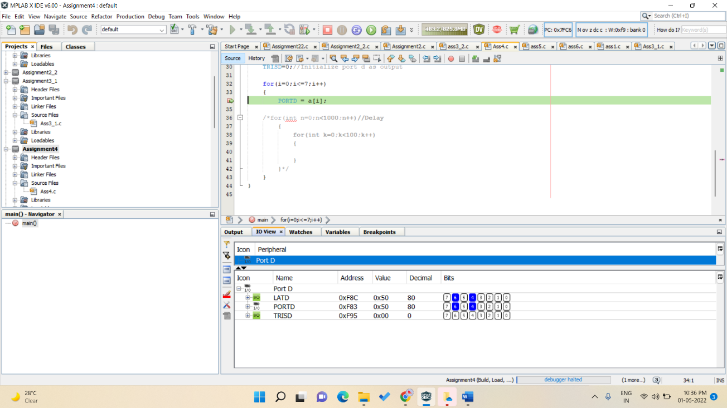

B]45

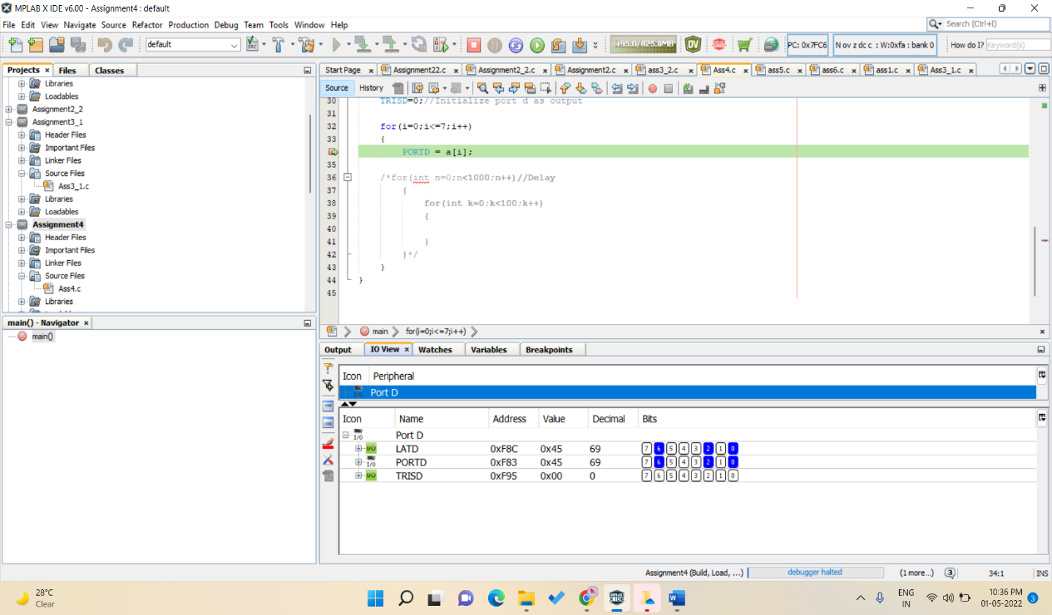

C]32

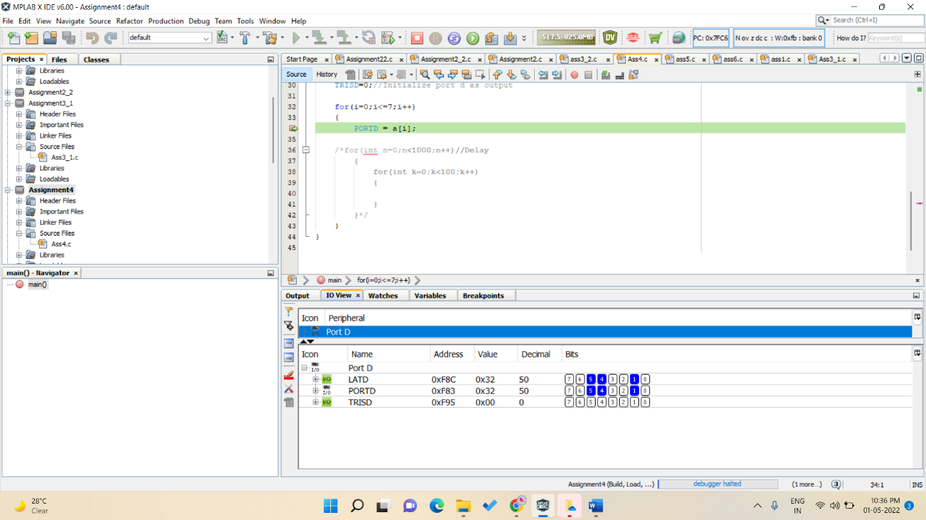

D]23

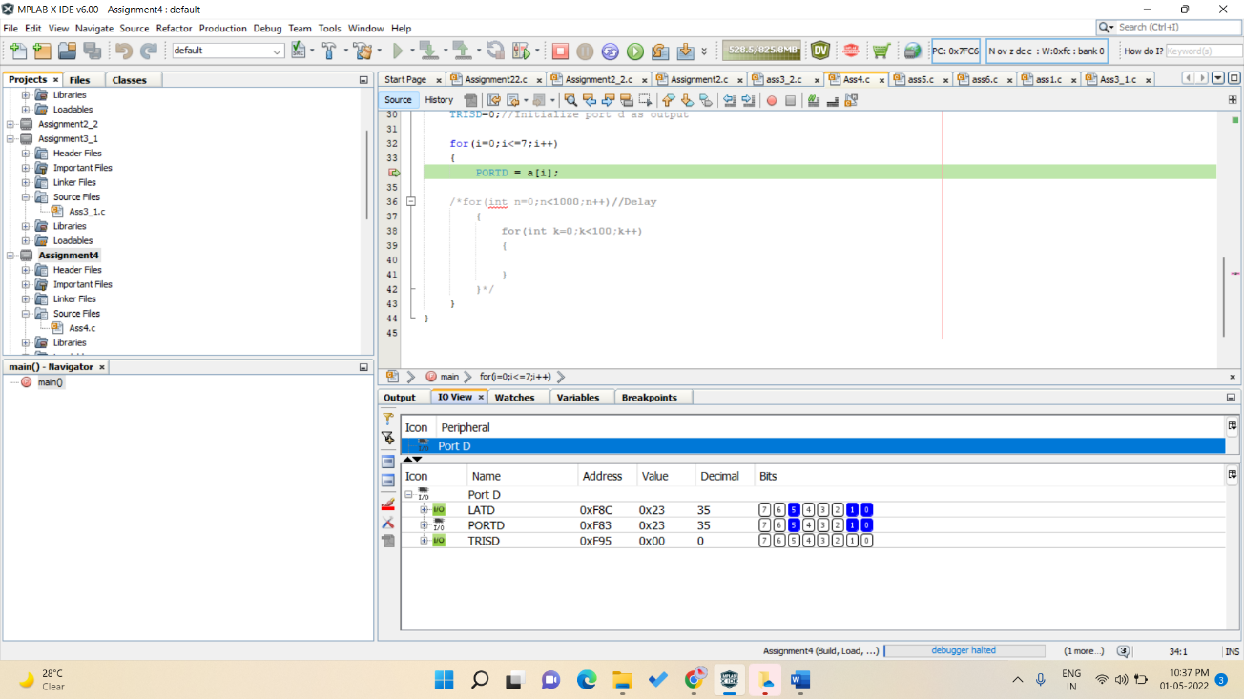

E]13

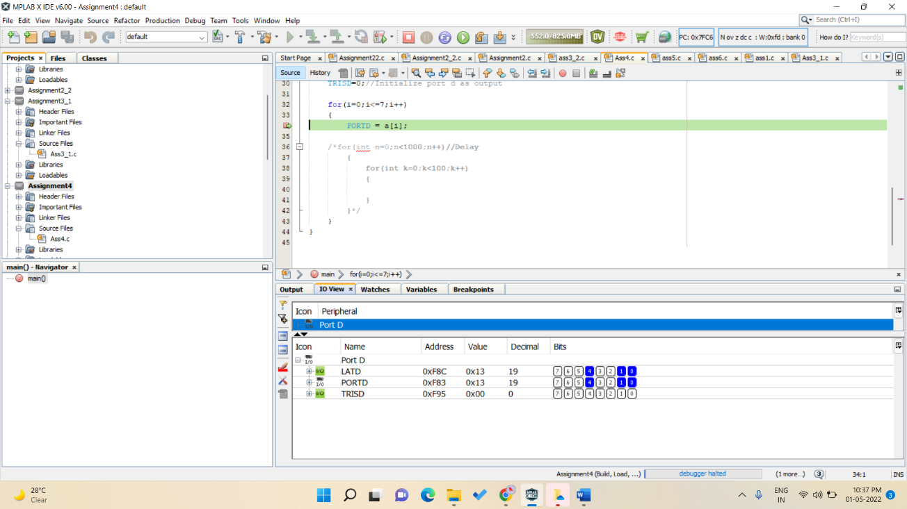

F]06

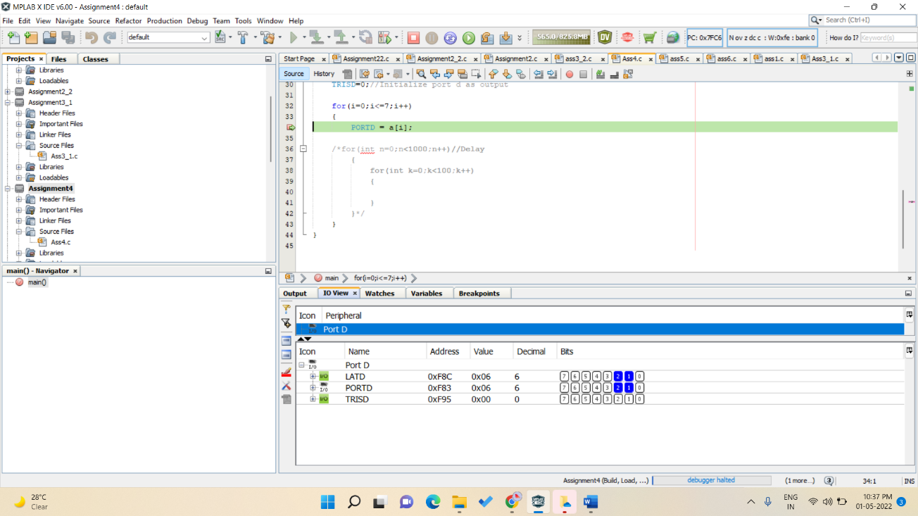

G]03

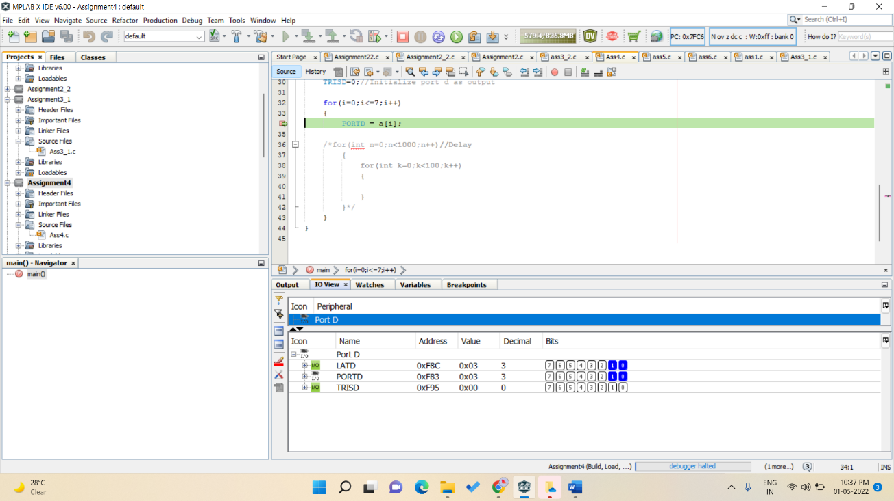

H]02

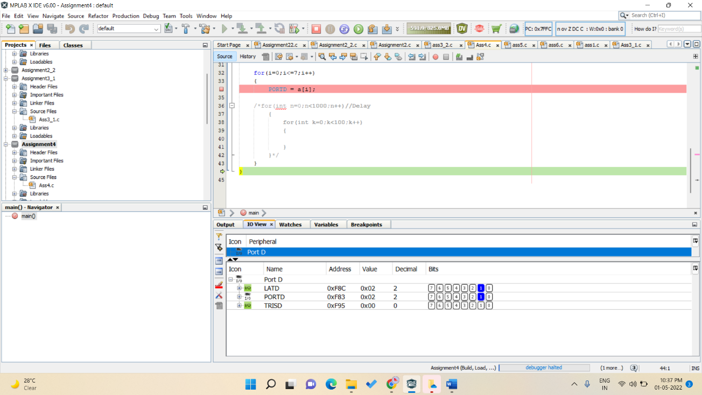

2) PICSIMLAB OUTPUT

A]50

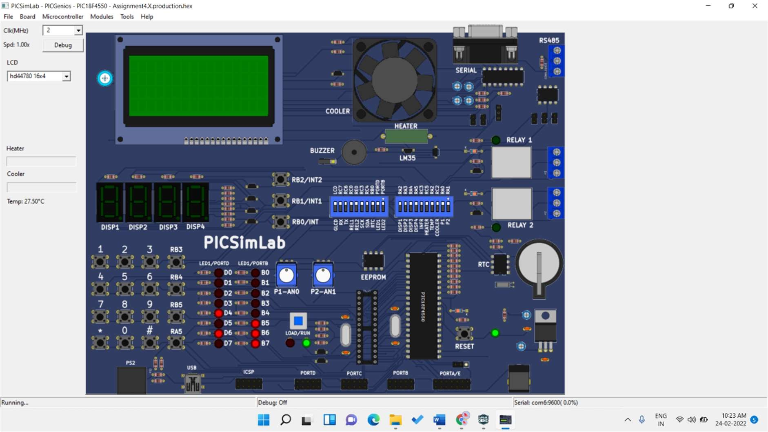

B]45

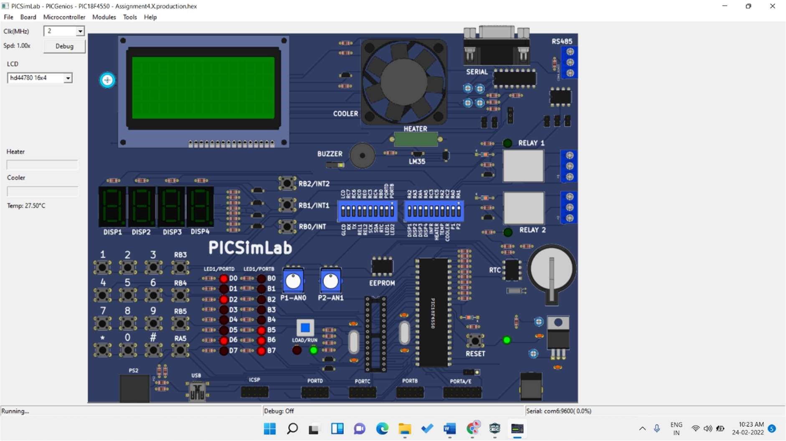

C]32

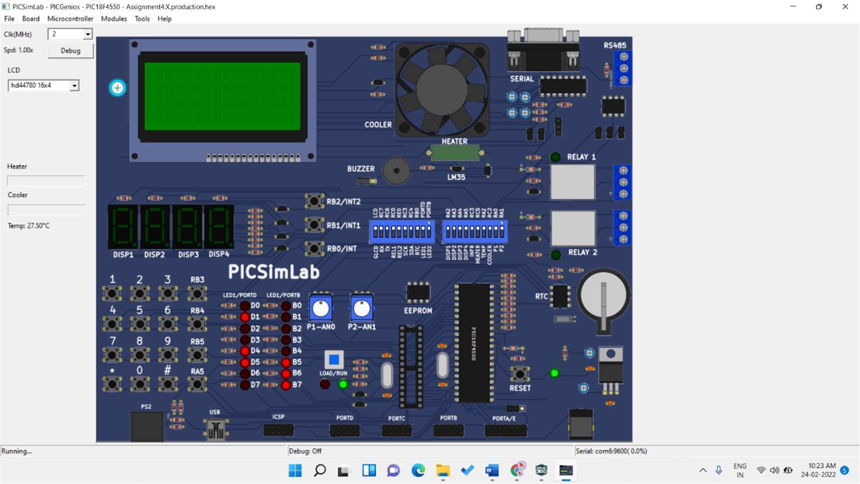

D]23

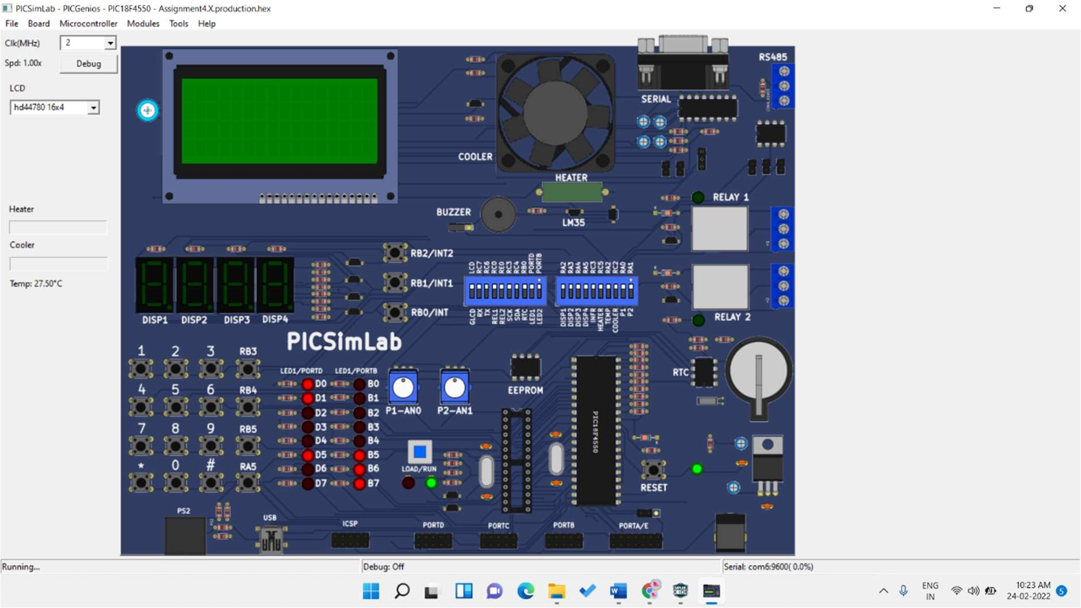

E]13

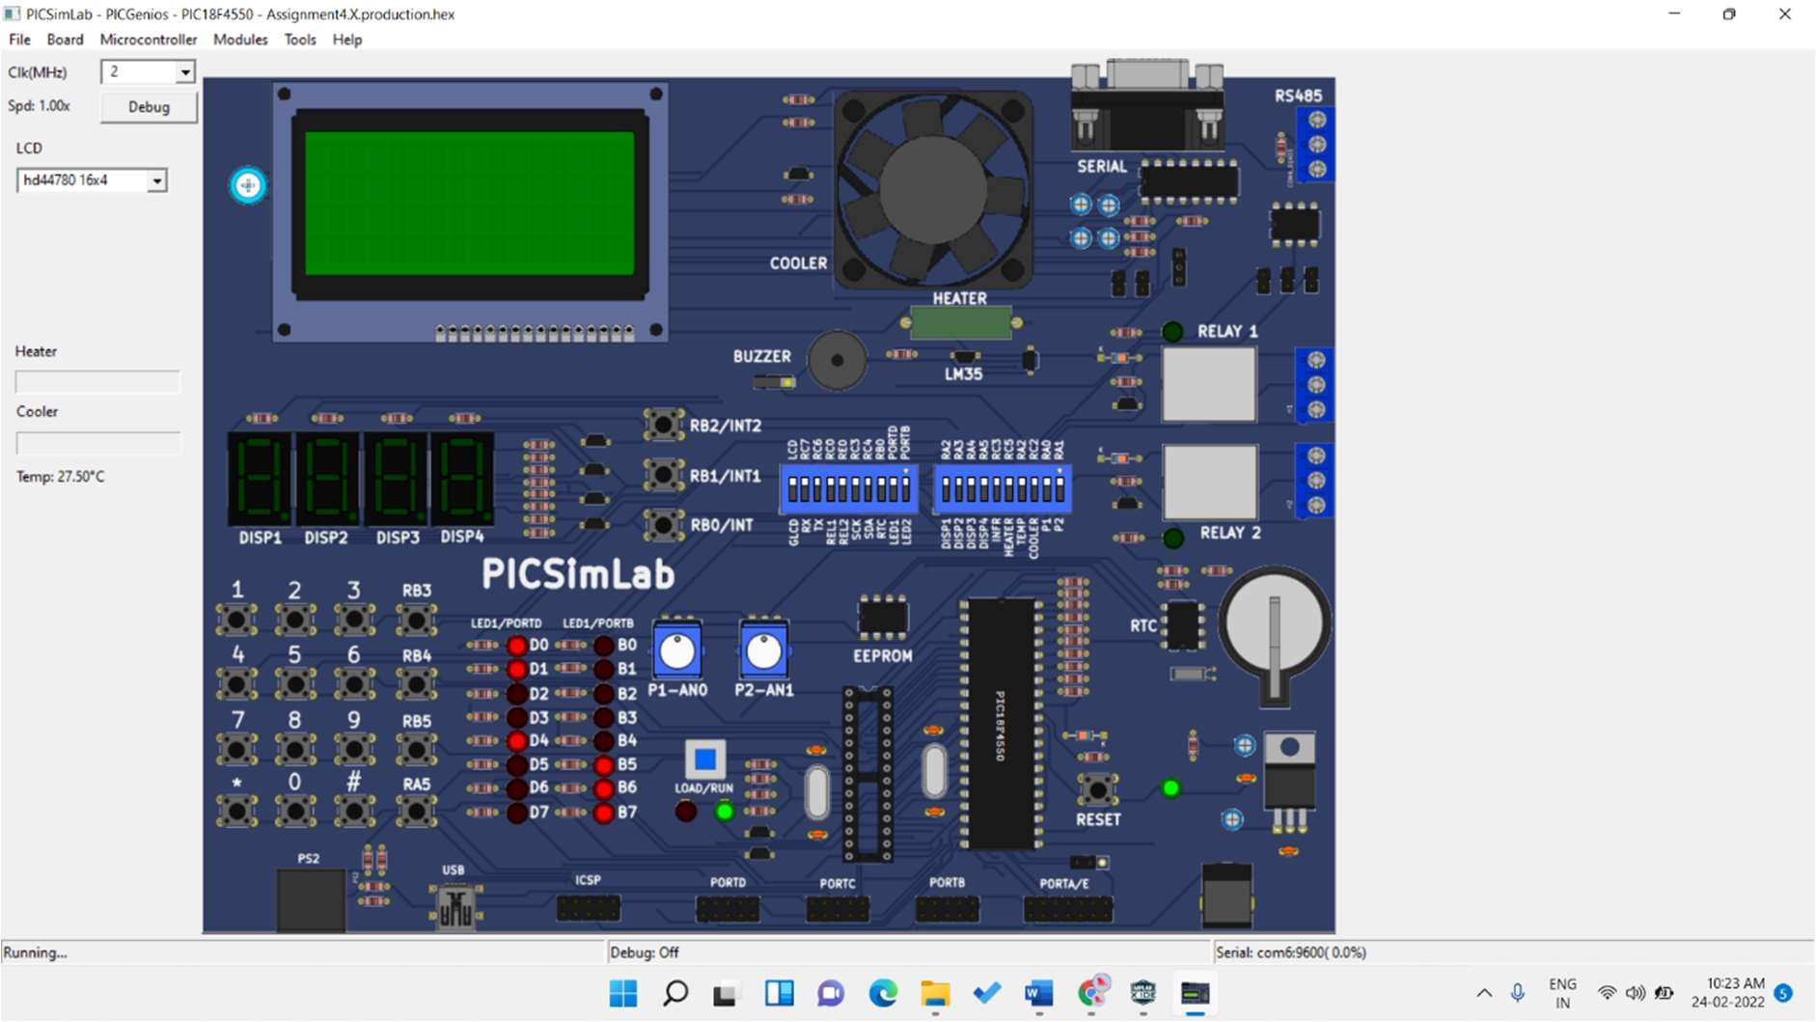

F]06

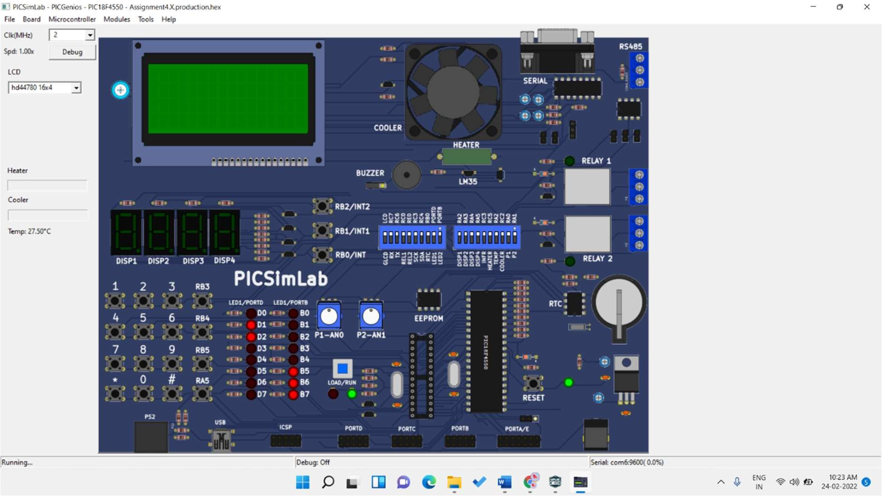

G]03

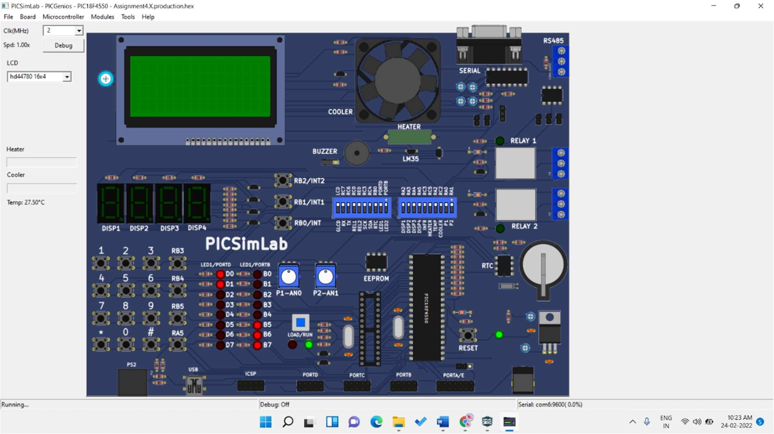

H]02

